I chose to use MongoDB for its flexibility in handling large amounts of data. Additionally, it is easy to interface with Python using the pymongo library. The Dash framework is used because it is a simple and straightforward framework for web applications with Python code. Another plus is that it integrates seamlessly with Plotly (an open-source graphing library that creates data visualizations like maps, plots, and dashboards) for creating a chart, map, or both! The steps that I took to make this all happen were as follows: First, step up MongoDB and the python environment. Second, Develop the CRUD (Create, Read, Update, and Delete) operations in “animal_shelter.py”. Third, build the dashboard layout by making specific search filters, data tables, and pie charts (As you’ll see below) in “ProjectTwoDashboard.ipynb”. Fourth, implement callbacks by adding interactivity to update charts and data tables based on the selected filter. Lastly, testing and debugging to ensure all components of the program work properly. More of the program is explained below:

Once loaded into the dashboard, you’ll be meet with this logo and title, then you can scroll down to view the dashboard.

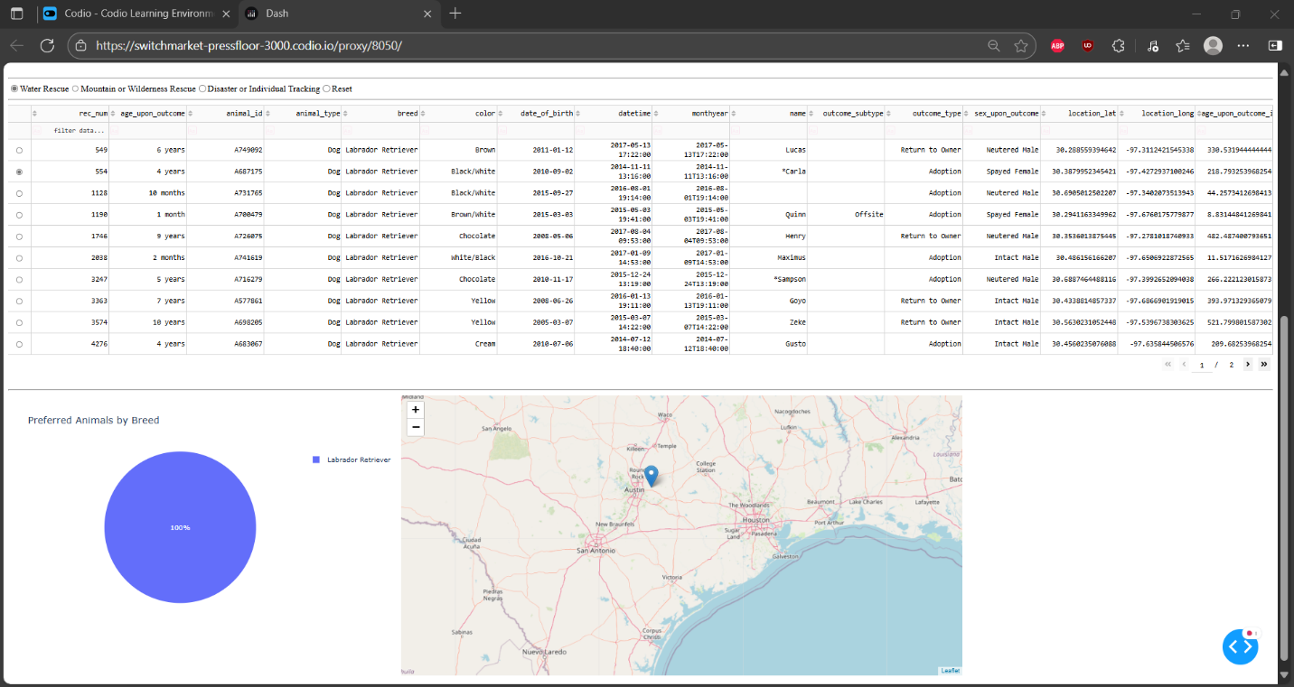

While using the dashboard, you’ll see data like the above example. This screenshot shows animals that were saved via Water Rescue. Additionally, I made a pie chart on the bottom left that shows the type of animals rescued via a percent by type of breed the animal is.

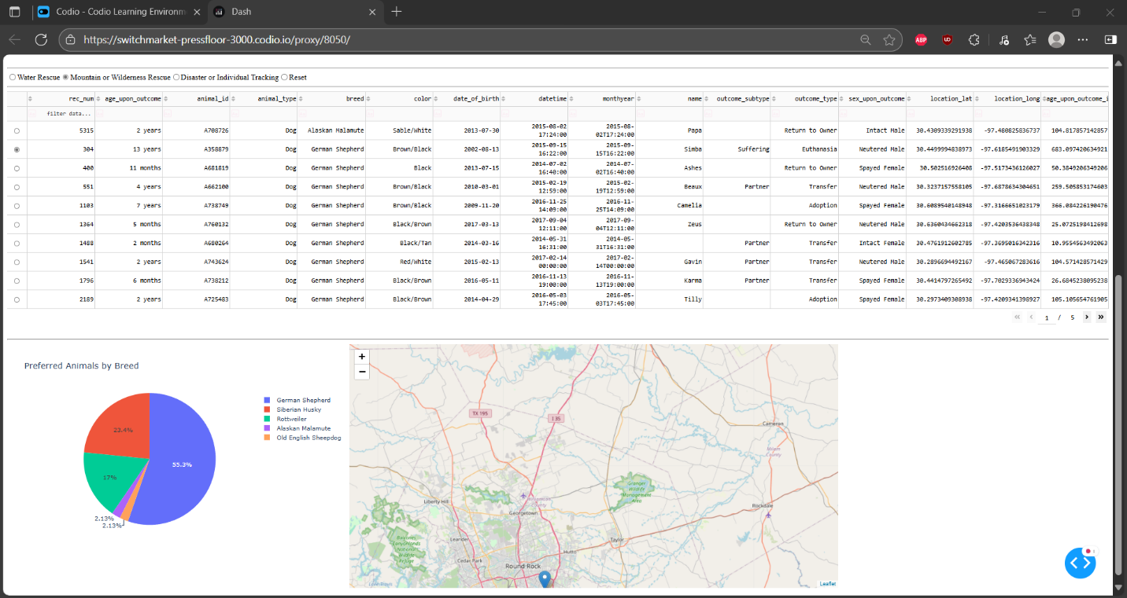

Another example, this time showing data relating “Mountain or Wilderness Rescue”.

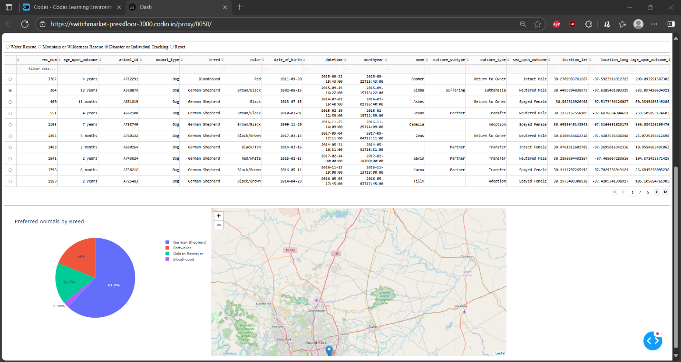

Another example, this time showing data relating “Disaster or Individual Tracing”.

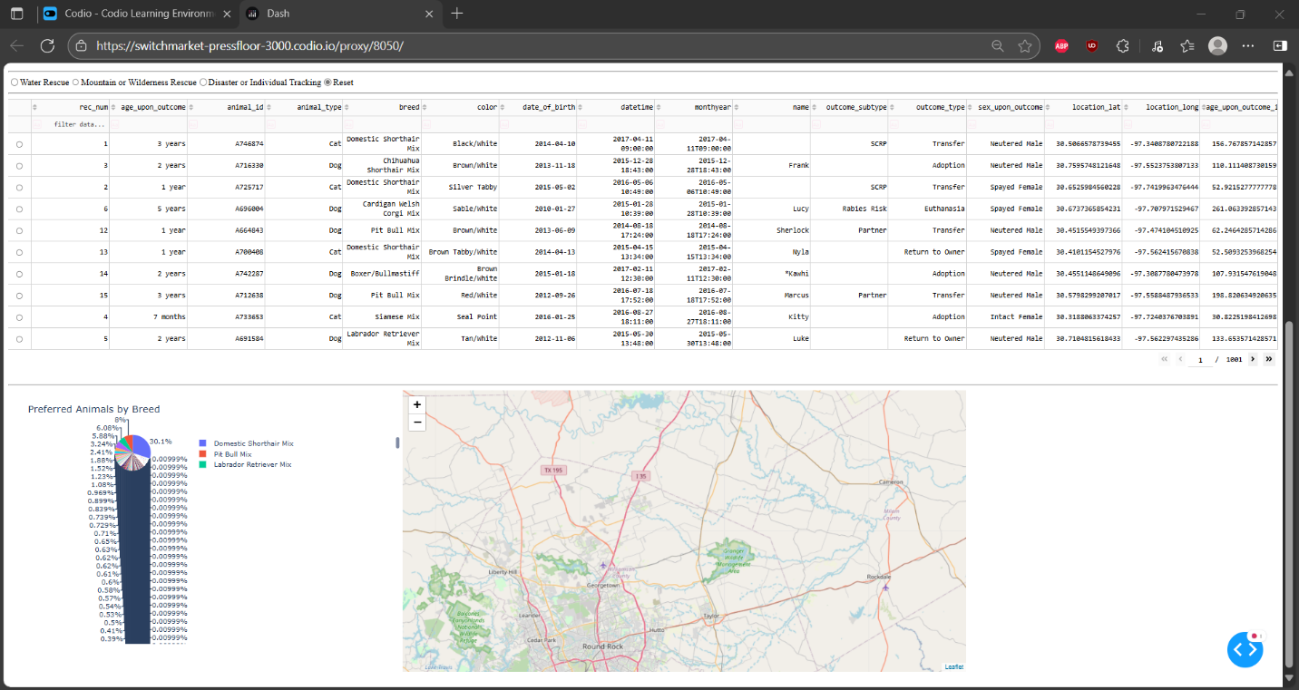

Lastly, selecting the “Reset” filter option will give you the above data.  
Some challenges that I ran into while creating this was the data tables not properly collecting the data as well as some interactive filter errors. I fixed the data tables error by fixing a typo that I had, and I fixed the interactive filter errors that by fixing a typo that I had.